CompTia A+
A+ - Peripherals and Power Supply
Assignment-5
Operating System information, windows, Linux, macOS installation and adjust OS settings
QUE-01 On your windows laptop or PC, open 'System Information' and take a screenshot showing your OS version, processor, and RAM details.
ANS
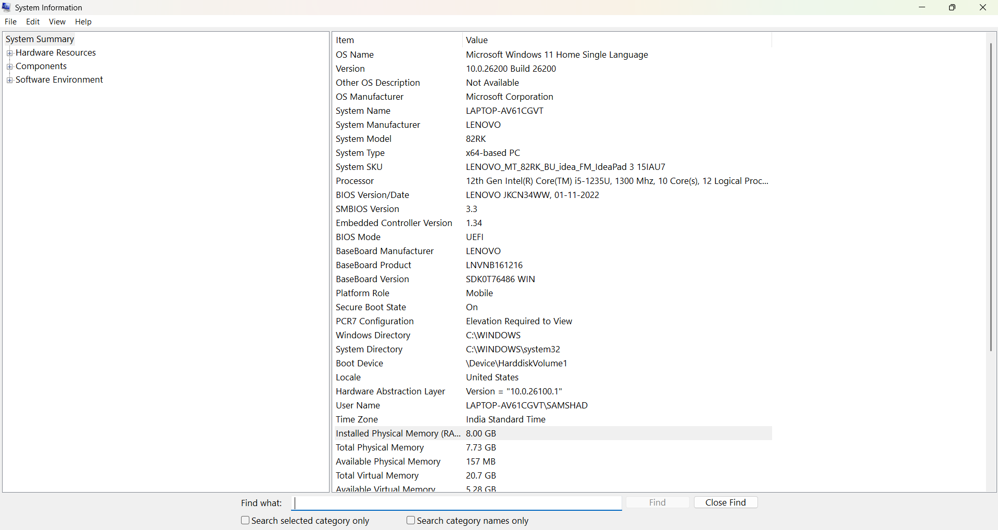

QUE-03 On a macOS device (or using a macOS virtual machine), open 'System Preferences' and change the desktop wallpaper, then adjust the system language to Hindi or Gujarati.<br><br><em><strong>Hint:</strong> Find 'Language & Region' in System Preferences to add or change languages.</em>
ANS
Changing Wallpaper and System Language in Windows
Steps to change the desktop wallpaper:
- Right-click on the desktop.
- Select Personalize.
- Click Background.
- Choose a picture or browse to select an image.
- The selected picture will appear as your desktop wallpaper.
Steps to change the system language to Hindi or Gujarati:
- Press Windows + I to open Settings.
- Select Time & language.
- Click Language & region.
- Select Add a language.
- Search for Hindi or Gujarati, select it, and click Next.
- Select Install. If available, choose it as the Windows display language.
- Sign out and sign back in if Windows asks you to do so.
Result: The desktop wallpaper is changed, and Hindi or Gujarati is added as a language. The Windows display language changes if the language pack and edition support it.

QUE-05 Use ChatGPT to generate a step-by-step guide for installing Windows 10 on a laptop, including partitioning tips and post-installation settings for privacy and updates. Follow the guide and note any steps that were unclear or missing.
ANS
Installing Windows 10 on a Laptop
Step 1: Prepare for installation
- Back up important files to an external drive or cloud storage.
- Keep the laptop connected to its charger.
- Download the Windows 10 ISO file from Microsoft's official website.
- Create a bootable USB drive (at least 8 GB) using the Media Creation Tool.
- Make sure you have your Windows product key if required.
Step 2: Boot from the USB drive
- Insert the bootable USB drive.
- Restart the laptop.
- Open the Boot Menu by pressing the appropriate key, such as F12, F9, Esc, or F2, depending on the laptop brand.
- Select the USB drive.
- Choose your language, time, and keyboard settings, then click Next.
- Click Install now.
Step 3: Install Windows
- Enter your product key, or select I don't have a product key if you will activate Windows later.
- Select the correct Windows edition if prompted.
- Accept the license terms.
- Choose Custom: Install Windows only (advanced) for a clean installation.
Step 4: Partition the hard drive
- Review the available disk partitions carefully.
- If you want a clean installation, delete or format partitions only after confirming that all important data is backed up.
- Select the unallocated space and click New if you want to create partitions manually.
- You can create a separate partition for Windows and another for personal files.
- Select the intended Windows partition and click Next.
Important: Deleting or formatting a partition permanently removes its data. On a laptop with existing recovery partitions, do not delete them unless you understand their purpose.
Step 5: Complete Windows setup
- Wait for Windows to copy files and restart.
- Follow the on-screen setup instructions.
- Choose your region and keyboard layout.
- Connect to Wi-Fi if available.
- Set up a Microsoft account or use an available local-account option.
- Create a strong password and configure sign-in options.
Step 6: Configure privacy settings
After installation, open Settings → Privacy and review:
- Location: Turn off if you don't need location-based services.
- Diagnostics & feedback: Choose the minimum diagnostic data option available.
- Advertising ID: Disable personalized advertising if desired.
- Background apps: Restrict apps that do not need to run in the background.
- Camera and microphone: Review which apps have permission to use them.
- Activity history: Review and disable collection options you don't need.
Step 7: Install updates and drivers
- Open Settings → Update & Security → Windows Update.
- Click Check for updates.
- Install available security and quality updates.
- Restart the laptop when requested.
- Install missing drivers from the laptop manufacturer's official website.
- Check Device Manager for devices with warning symbols.
Important: Windows 10's standard support ended on October 14, 2025. For a new installation in 2026, consider Windows 11 if your laptop supports it, or check Microsoft's current extended security update options for Windows 10.
Step 8: Final checks
- Confirm Windows activation under Settings → Update & Security → Activation.
- Check Wi-Fi, sound, webcam, touchpad, and USB ports.
- Install a browser and other required applications.
- Verify that your files and backups are accessible.
Steps that may be unclear or missing
Step | Possible issue or missing detail
Creating a bootable USB | The exact tool and download instructions may vary.
Opening the Boot Menu | The key differs by laptop manufacturer.
Partitioning | The correct partition size depends on disk capacity and personal needs.
Product key | Activation requirements depend on the Windows license.
Local account setup | Options can vary by Windows version and setup method.
Drivers | Some laptops require manufacturer-specific drivers.
Windows updates | Windows 10 support has ended, so current security coverage needs checking.
Conclusion: A successful installation requires a bootable USB, careful partition selection, correct drivers, and appropriate privacy and update settings. Always back up your data before changing partitions.

